

Student Name……………………………………

FURTHER MATHEMATICS

WRITTEN TRIAL EXAMINATION 2

2008

Reading Time: 15 minutes
Writing time: 1 hour 30 minutes

Instructions to students
This exam consists of Section A and Section B.
Section A contains a set of extended answer questions from the core, 'Data Analysis'.
Section A is compulsory and is worth 15 marks.
Section B begins on page 7 and consists of 6 modules. You should choose 3 of these modules and answer every question in each of your chosen modules. Each of the modules is worth 15 marks.
Section B is worth 45 marks.
There is a total of 60 marks available for this exam.
The marks allocated to each of the questions are indicated throughout.
Students may bring one bound reference into the exam.
An approved graphics or CAS calculator may be used in the exam.
Formula sheets can be found on pages 35 and 36 of this exam.
Unless otherwise stated the diagrams in this exam are not drawn to scale.

This paper has been prepared independently of the Victorian Curriculum and Assessment Authority to provide additional exam preparation for students. Although references have been reproduced with permission of the Victorian Curriculum and Assessment Authority, the publication is in no way connected with or endorsed by the Victorian Curriculum and Assessment Authority.

© THE HEFFERNAN GROUP 2008

This Trial Exam is licensed on a non transferable basis to the purchasing school. It may be copied by the school which has purchased it. This license does not permit distribution or copying of this Trial Exam by any other party.

Section A

Core

This section is compulsory.

Question 1

The boxplot below shows the weekly pay of employees of a small business.

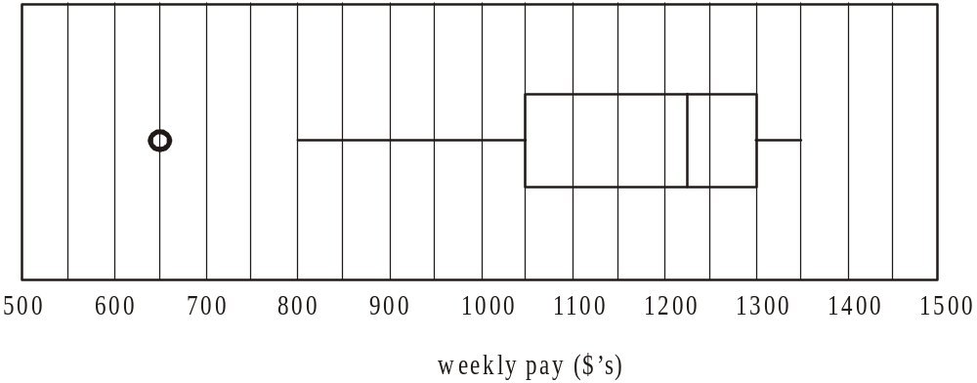

- Describe the shape of the boxplot.

1 mark

- What is the interquartile range of the distribution?

1 mark

- Using a calculation, justify why the piece of data 650 has been represented as an outlier.

1 mark

Question 2

The table below shows the age and weekly pay of employees at another small business.

Age  (years) | Weekly Pay  ($’s)
18 | 800
22 | 850
24 | 1050
30 | 1050
31 | 1150
35 | 1300
38 | 1250
42 | 1300
44 | 1350
48 | 1200
52 | 1350
54 | 1250

This data has been used to create the scatterplot below.
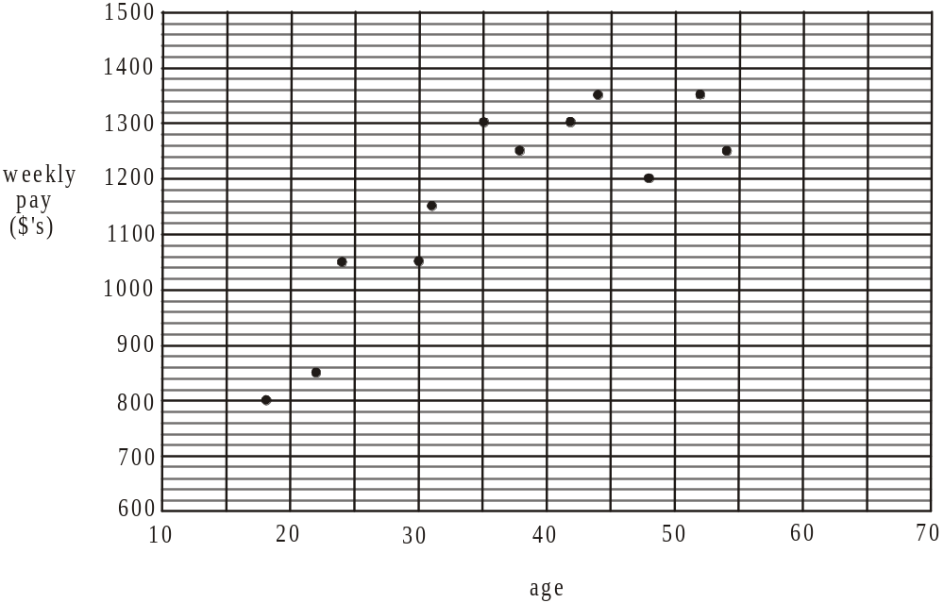

- Find the value of r; Pearsons correlation coefficient. Express your answer correct to 4 decimal places.

1 mark

- Find the coefficient of determination for the data. Express your answer correct to 3 decimal places.

1 mark

- Find the percentage of the variation in weekly pay that can be accounted for by the variation in age. Express your answer correct to the nearest whole percent.

1 mark
- i. Find the equation of the least squares regression line for this data. Use the variable names, age and weekly pay in the equation and express any coefficients correct to two decimal places.

  - Plot the least squares regression line that you have found on the scatterplot on page 3.

A residual plot is constructed and is shown below.

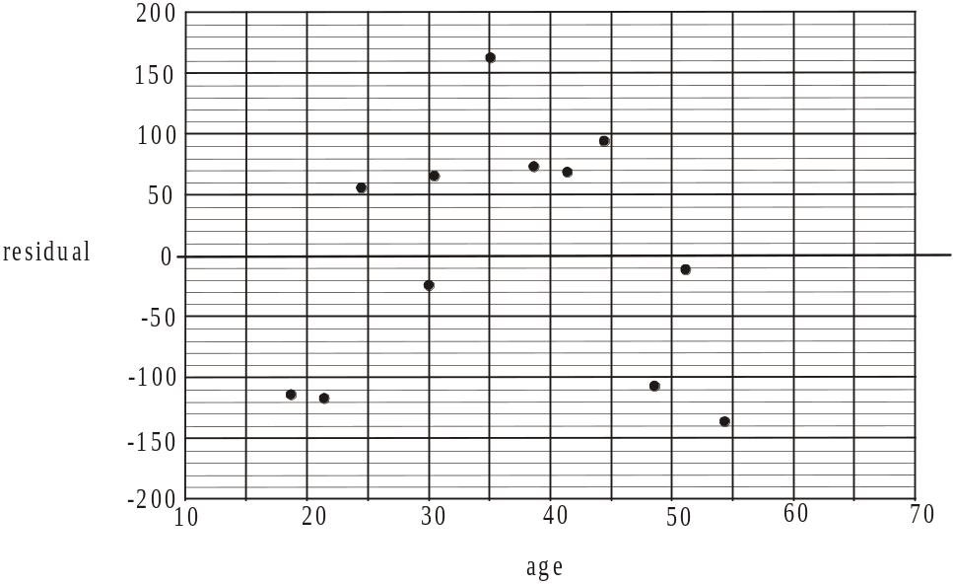

- Using your least squares regression line equation and the table, show how the residual value for the employee aged 54 years was calculated.

1 mark

- What aspect of the residual plot suggests that the assumption that the relationship between age and weekly pay is linear, is incorrect?

1 mark

- Suggest a transformation that could be used in an attempt to linearise the data.

1 mark

Question 3

Rod has been a casual employee of the business for a number of years. His quarterly net pay is shown on the time series plot below.

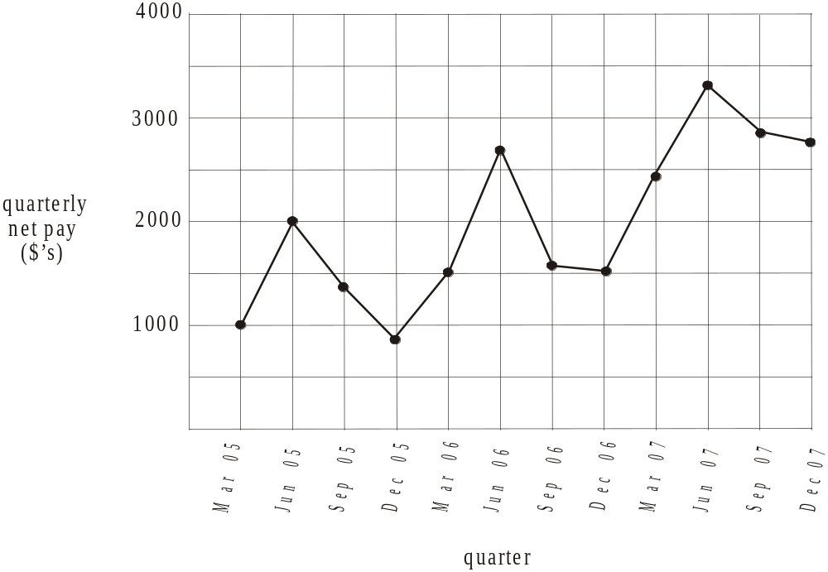

- Describe the variation shown in the time series plot.

1 mark

- Use three-median smoothing to smooth the time series plot shown. Plot the smoothed series on the same graph.

2 marks
Total 15 marks

SECTION B

Module 1: Number patterns

If you choose this module all questions must be answered.

Question 1

Jane has started a gym program. At her first session she does twelve sit-ups and increases this by five at each session that follows.

- How many sit-ups will Jane do at her third session at the gym?

1 mark

- At which gym session will Jane first complete more than fifty sit-ups?

1 mark

The number of sit-ups; 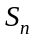, that Jane completes at her 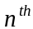 gym session is given by the equation 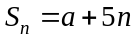.

- Find a.

1 mark

- Jane’s gym instructors set a limit of 150 sit-ups for her in a session. During which session will she reach this limit?

1 mark

Question 2

Jane’s partner Michael also joins the gym. The total of the weights, in kgs, he lifts in a gym session follows a geometric sequence and the totals for his first three sessions are shown in the table below.

gym session | 1 | 2 | 3
total of weights lifted (kg) | 100 | 110 | 121

- Show that the common ratio of this sequence is given by .

1 mark

- Write an equation that gives the total of weights lifted in a session 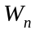, at Michael’s session at the gym.

1 mark

- At which of Michael’s gym sessions will he first lift a total of more than 200kg?

1 mark

- Find the total of weights lifted by Michael from his 10th gym session to his 15th gym session inclusive.
Express your answer to the nearest kg.

2 marks

Question 3

The time 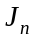, in minutes, that Jane spends at her gym session is described by the difference equation

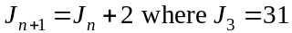

- How many minutes does Jane spend at the gym for her first session?

1 mark

- What sort of sequence is described by the difference equation above? Justify your answer.

1 mark

- Find the total time that Jane spends at her first 12 sessions at the gym.

1 mark

Question 4

The time, in minutes that Jane and Michael each spend at each of their first twenty gym sessions is shown on the graph below.

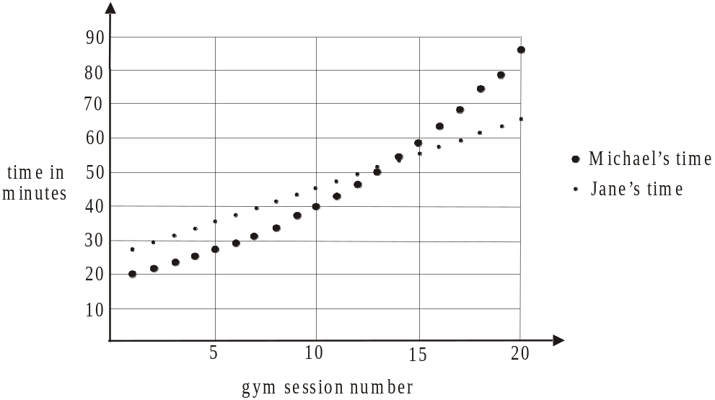

  - How many more minutes than Michael does Jane spend at the gym during session 1?

1 mark

  - Which is the first session where Michael spends more time at the gym than Jane?

1 mark

  - At which session is the difference in the time that Jane and Michael each spend at the gym, the greatest?

1 mark
Total 15 marks

Module 2: Geometry and trigonometry

If you choose this module all questions must be answered.

Question 1

A building is under construction and the side view of the building is shown in the diagram below.
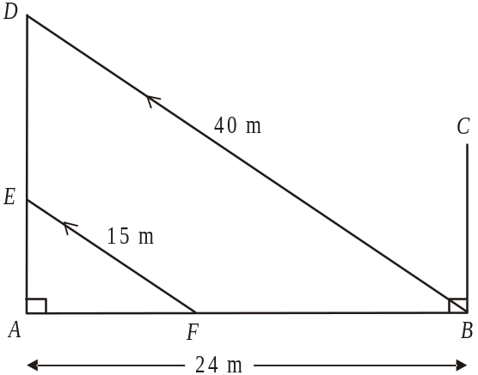

The vertical walls BC and AD are already in place and steel poles indicated by BD and FE run parallel to one another and are used to prop up the wall AD during construction. The base AB is 24m long, the steel pole FE is 15m long and the pole BD is 40m long.

- Find the height of the vertical wall AD.

1 mark

- Find the distance AF in metres.

1 mark

- Find the angle that the steel pole BD makes with the base AB. Express your answer to the nearest minute.

1 mark
- Find the ratio of the area of .

1 mark

Question 2

The building is to be in the shape of a rectangular prism with a triangular prism on top as shown in the diagram below.

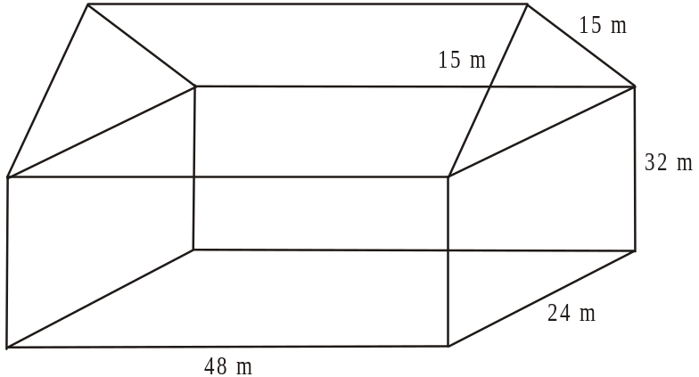

The slant sides of the triangular prism are both 15m in length.

- Find the surface area of the building excluding the rectangular base.

2 marks

- Find the volume of the building.

1 mark

A scale model of this building was made and the longest side on the base of the scale model had a length of 2m.

- Find the ratio of the volume of the scale model to the volume of the actual building.

1 mark

It is calculated that the volume of the scale model is 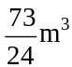.

- Use your answer to part c. to show that your answer to part b. which gives the volume of the actual building is correct.

1 mark

Question 3

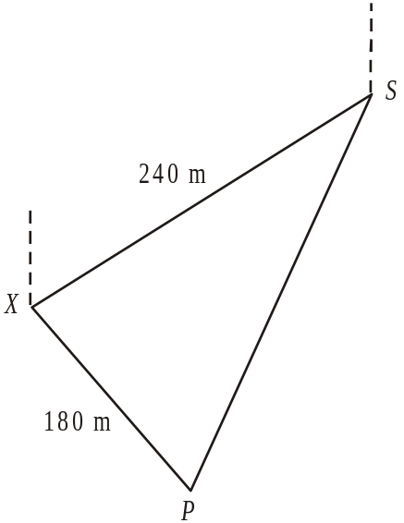

In the diagram above, the building under construction is located at point X.
In relation to point X, the bearing of the train station, S, is 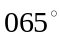 and a direct distance of 240m away. Also, a post office P, is on a bearing of 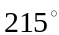 from the station and its direct distance from X is 180m.

- Explain why 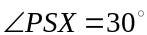.

1 mark

- Find . Express your answer to the nearest minute.

1 mark

- Use the cosine rule to find the distance PS. Express your answer to the nearest metre.

2 marks

- What is the bearing of the Post Office, P, from the building under construction at X? Express your bearing to the nearest degree.

1 mark

- Find the area of . Express your answer in 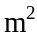 correct to one decimal place.

1 mark
Total 15 marks

Module 3: Graphs and relations

If you choose this module all questions must be answered.

Question 1

Kristy runs a hairdressing salon for men and women. The temperature in the salon is affected by the hair dryers that operate in the salon as well as the heating/air conditioning and the outside temperature.
A graph showing the temperature in the salon on a particular day is shown below.
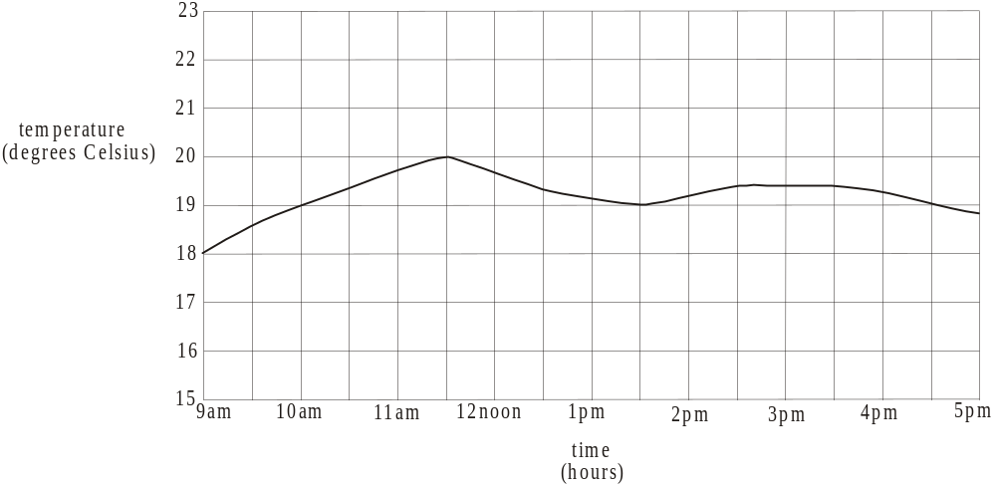

- What is the temperature in the salon at 1.30pm?

1 mark

- During which hour of the day does the temperature rise most quickly?

1 mark

- i. What is the maximum temperature in the salon during the day?

  - At what time does this maximum temperature occur?

Question 2

Kristy employs fully trained hairdressers and apprentices at the salon.

Let x be the number of male clients at the salon in one day.
Let y be the number of female clients at the salon in one day.

On average it takes 15 minutes of a hairdresser’s time for each male client and 20 minutes for each female client. There are a total of 600 minutes of hairdressers’ time available in a day at the salon. Also it takes an average of 10 minutes of an apprentices’ time for each male client and 40 minutes for each female client. There are a total of 800 minutes of apprentice time available in a day at the salon.
The information above can be expressed using the inequalities below.
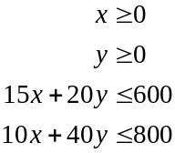
The diagram below shows two straight lines A and B which form the boundaries of two of the inequalities.
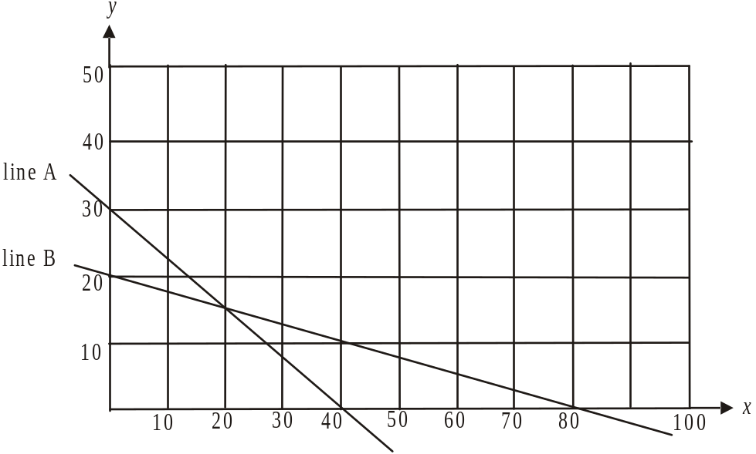

- Write down the inequality for which line A forms the boundary.

1 mark

- Write down the coordinates of the point of intersection of these two graphs.

1 mark

- Shade the feasible region described by the four inequalities.
1 mark
- The profit made by Kristy on each male client is on average $15 and for female clients it is $25.

- Write down an equation for the profit P.

- How many male clients and female clients are needed in a day if the profit is to be a maximum?

Due to illness, the number of minutes of apprentice time available in a day drops to 450. Also the time that an apprentice spends on a male client is reduced to 5 minutes and the time spent on a female client is reduced to 30 minutes.

- Write down a new inequality that describes this information.

1 mark

- On the set of axes below, sketch the straight line that forms the boundary of the inequality found in part e..

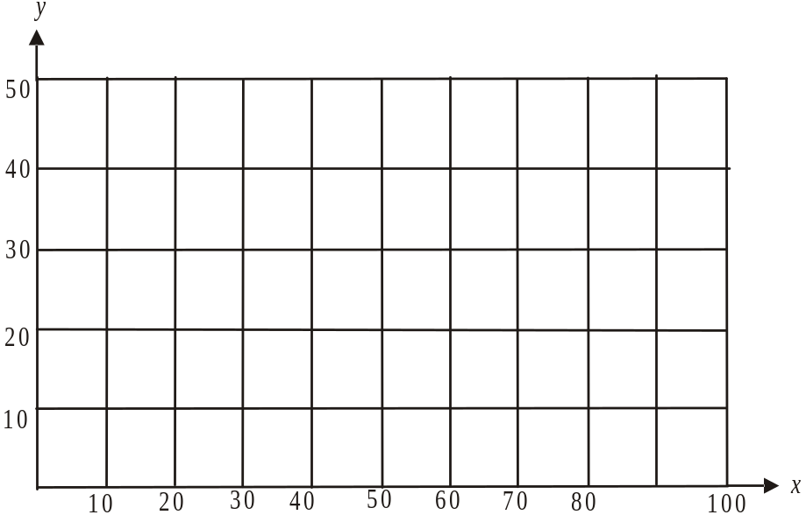

1 mark

Question 3

At the basins in Kristy’s salon, the water runs from the taps at a constant rate. The graph below shows the typical consumption of water whilst a client is at a basin.

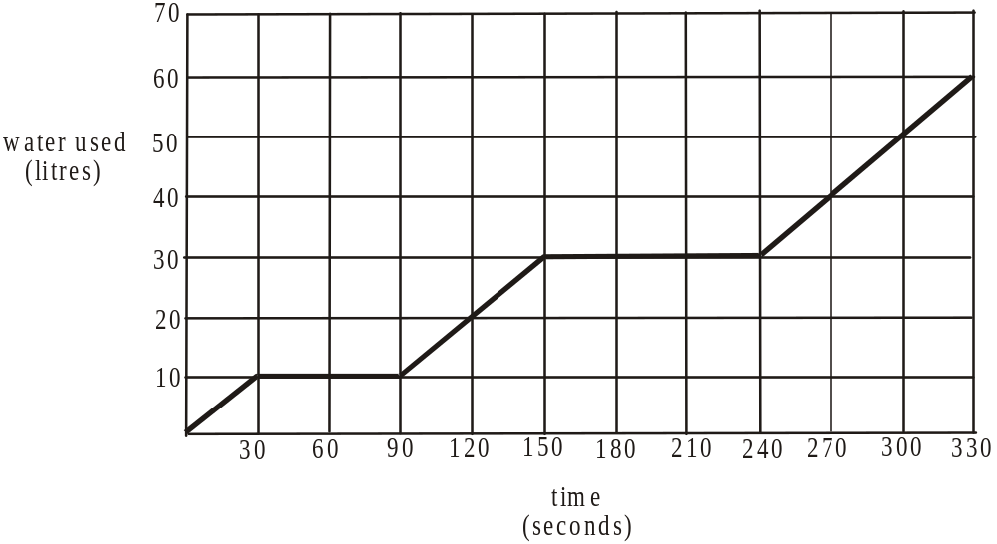

Typically, a client has their hair made wet, shampoo is applied and rinsed off and finally conditioner is applied and rinsed off. The tap is turned off whilst the shampoo and conditioner are applied.

- What is the constant rate at which the water flows, in litres/second, from one of the taps at the basin?

1 mark

- How long does it take to apply the conditioner?

1 mark

- How much water is used to rinse off the conditioner?

1 mark

- What is the total time that the tap is turned on?

1 mark
Total 15 marks
Module 4: Business-related mathematics

If you choose this module all questions must be answered.

Question 1

Marco bought an investment property in 1996 for $160 000 and sold it in 2007 for $730 000.

- Find the percentage increase in the value of the property between 1996 and 2007.

1 mark

Marco has to pay capital gains tax at the rate of 46% on any capital gains his investments make.

- How much capital gains tax does Marco have to pay on the investment property he sold? (Assume there were no costs incurred in the sale.)

1 mark

Nick purchased Marco’s investment property and he had to pay stamp duty according to the schedule below.

Price paid for property | Stamp duty rate payable
$0 - $25 000 | 1.4% of price paid
$25 001 - $130 000 | $350 plus 2.4% of price paid over $25 000
$130 001 - $960 000 | $2 870 plus 6% of price paid over $130 000
$960 000 - | 5.5% of price paid

- How much stamp duty did Nick have to pay for his $730 000 purchase of Marco’s property?

1 mark

Question 2

Marco runs a restaurant business and is about to purchase equipment for the kitchen valued at $12 000. He can buy equipment from a wholesaler for cash at a discount of 7%.

- How much will Marco pay for his kitchen equipment if he buys it from his wholesaler?

1 mark

A second option is to buy from a retail store paying a deposit of $1 000 and making quarterly instalments of $1 050 for 3 years.

- i. How much will Marco pay in total for the equipment over the 3 years?

  - What flat rate of interest does this deal offer? Express your answer as a percentage correct to 2 decimal places.

A third option is for Marco to buy the $12 000 worth of equipment using his credit card. If he pays the $12 000 off within 30 days, no interest is charged. Any of the $12 000 not paid off within 30 days has interest charged on it at the rate of 21% per annum calculated monthly.

- Suppose Marco were to pay $6 000 within 30 days of purchase of the equipment and the remaining $6 000 within thirty days after that. How much interest will he be charged on the purchase?

1 mark

Question 3

Marco’s $12 000 kitchen equipment is to be depreciated for taxation purposes using flat rate depreciation at the rate of 12% per annum.

- i. How much will the kitchen equipment depreciate each year?

  - How many years will it take for the equipment to be valued at $4 800?

- If Marco were to use reducing balance depreciation at the rate of 12% per annum, during which year would the equipment be worth $4 800?

2 marks

Question 4

Marco wants to change the restaurant’s fit-out. He borrows $120 000 at 9.5% per annum interest compounding quarterly.
Marco pays regular instalments to the bank at the end of each quarter and intends having the loan paid out after 4 years.

- What quarterly instalment does Marco pay the bank? Express your answer to the nearest cent.

1 mark

- How much interest does Marco pay over the course of his loan?

1 mark

- How much interest would Marco save if he paid the loan off in 2 years?

2 marks
Total 15 marks

Module 5: Networks and decision mathematics

If you choose this module all questions must be answered.

Question 1

A collection of sports ovals are scattered throughout parklands. The seven ovals indicated by the letters A – G are shown on the network below together with the distances, in metres that connect them along bike paths.

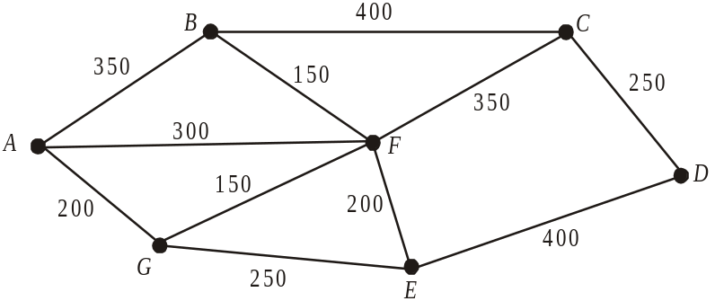

- What is the degree of vertex F?

1 mark

Paul starts riding at A and completes a Hamiltonian circuit.

- Write down a possible route that Paul may have taken.

1 mark

- Explain why an Euler circuit does not exist for this graph.

1 mark

Jordan starts riding at A and wants to finish at D.

- What is the shortest route Jordan can take?

1 mark

Question 2

A partial upgrade of the bike paths is to be undertaken. Initially, until extra funds can be found, only some of the current bike paths will be resurfaced. Those to be resurfaced form a minimum spanning tree.

- On the outline of the graph below, draw the minimum spanning tree.

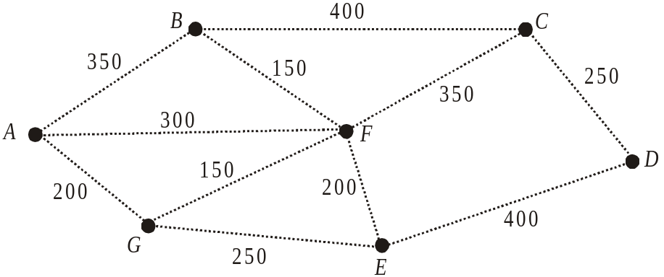

1 mark

- What is the total length of bike paths to be resurfaced initially?

1 mark

Question 3

Part of the parkland area where the ovals are situated is subject to flooding.
A system of drains that run through some of the parklands is shown below with the capacity, in litres/sec, that each section of drain has, indicated on the corresponding edge.

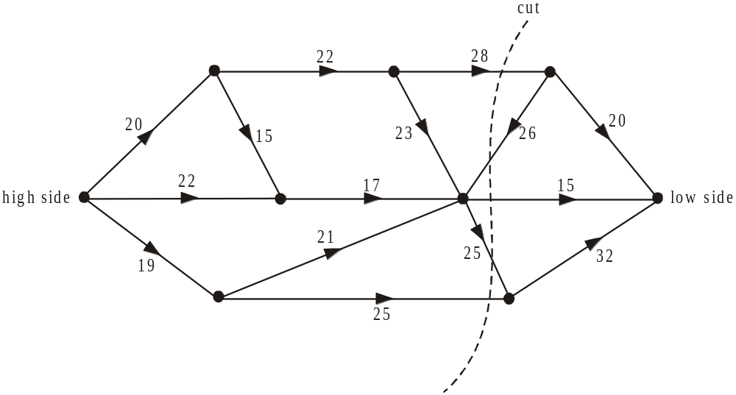

A cut has been made through the network as shown above.

- Find the capacity of the cut shown.

1 mark

- What is the maximum capacity of this network of drains from the high side to the low side of the parklands?

1 mark

Question 4

At one of the ovals in the parklands a cricket club is building clubrooms.
The twelve activities required for the building of these clubrooms, together with the time in weeks taken to complete them, is shown on the directed network below.

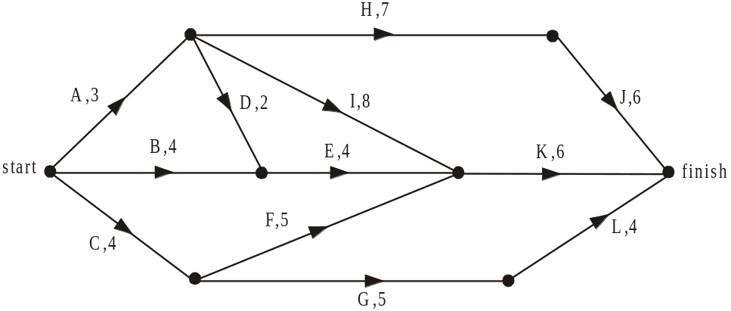

- What is the earliest start time for activity K?

1 mark

- What is the latest start time for activity D?

1 mark

- What is the minimum time; in weeks, that it will take to build the clubrooms?

1 mark

- What is the float time for activity F?

1 mark

The cricket club wishes to have the clubrooms finished earlier in readiness for the start of the cricket season.
The builders advise that only four of the activities can be reduced in time. These four activities are A, B, I and L. Each of the activities can be reduced by just one week.

- Which of the four activities listed, would individually, reduce the overall completion time of the project, if their time was reduced by one week?

1 mark

- Assuming that the builders now reduce by one week, the time taken for each of the activities A, B, I and L, what is the minimum completion time now for the project?

1 mark

- Which of the twelve activities involved in the project are now critical to the project being completed by this new, reduced time?

1 mark
Total 15 marks
Module 6: Matrices

If you choose this module all questions must be answered.

Question 1

At Riverbank Secondary College there is one class each of Year 12 Further Maths, Accounting, Biology and Physical Education. The students in each of these classes are spread across the four Year 12 homeroom classes 12A – 12D as indicated in the table below.

Year 12 class | 12A | 12B | 12C | 12D
Further Maths | 4 | 5 | 6 | 7
Accounting | 3 | 6 | 2 | 5
Biology | 6 | 8 | 7 | 4
Physical Education | 8 | 3 | 4 | 2

Consider the matrices 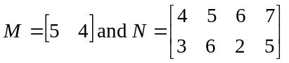

- i. Find the matrix product MN.

- Explain why the matrix product NM does not exist.

- If P is a matrix, what is the order of the matrix product NP?

In the Further Maths class an assessment task may not exceed five pages in length and in the Accounting class an assessment task may not exceed four pages.
The same teacher teaches Further Maths and Accounting and is the 12C homeroom teacher.

- What is the maximum number of pages that this teacher will have to assess for these two assessment tasks in those two subjects for her students in 12C?

1 mark

One particular night a set task to be completed at home was given to students in each of the Further Maths, Accounting, Biology and Physical Education classes. All the students completed these set tasks as required.
In 12A students studying these four subjects spent a combined total of 530 minutes on the set tasks. In 12B the total was 550 minutes, in 12C it was 425 minutes and in 12D it was 460 minutes.
Let the time limit, in minutes, for each of the set tasks be represented by f for Further Maths, a for Accounting, b for Biology and p for Physical Education.
The time limit for each set task in each of the four subjects can be found by solving the matrix equation.

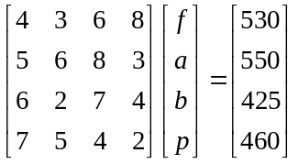

- Solve this matrix equation to find the values f, a, b and p.

2 marks

Question 2

A research project looked at the main occupation of a sample of people all aged twenty-one when the research project began.
The categories of full-time study (s), full-time paid work(w) and other activities (o), such as volunteer activities, child-care and so on were used in the project.
The number of people engaged in study, work or other activities at the start of the project is given by initial state matrix 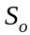 where

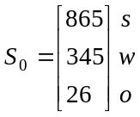

- How many people were studied in this project?

1 mark

Using data from similar groups together with interview data, a transition matrix T, was created.
This matrix models the anticipated movements of this group between study, work and other activities into the future.
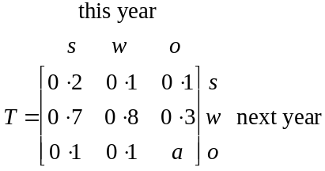

- Explain why .

1 mark

- What proportion of people in the research project who are currently studying are predicted to be working next year?

1 mark

- i. If 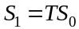, find the matrix .

  - How many of the people involved in the research project moved from other activities to full-time work in the first year of the project?
Express your answer to the nearest whole number.

- How many people involved in the research project are expected to be working after five years? Express your answer to the nearest whole number.

1 mark

- Find the steady state matrix for this group involved in the research project.

1 mark

An identical research project was begun one year previously involving a different group of twenty-one year olds.
The same transition matrix T is used in both projects where

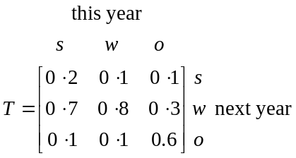

The initial state matrix for the earlier study was given by

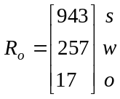

Let 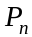 be a matrix showing the total number of people in both research projects who are studying full-time, working full-time or involved in other activities n years after the first of the two research projects began

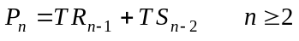

- Calculate 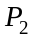.

1 mark

- What is the total number of people involved in both research projects who are in full-time work two years after the first of the two projects began. Express your answer to the nearest whole number.

1 mark
Total 15 marks
Further Mathematics Formulas

Core: Data analysis

standardised score: 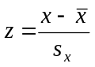
least squares line: 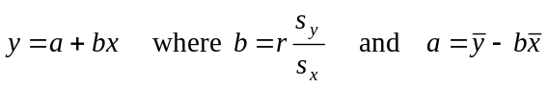
residual value: residual value = actual value – predicted value

seasonal index: seasonal index 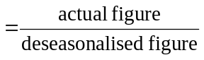

Module 1: Number patterns

arithmetic series: 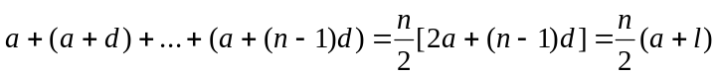
geometric series: 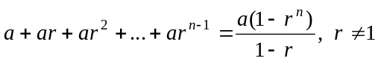
infinite geometric series: 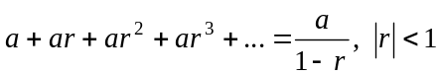

Module 2: Geometry and trigonometry

area of a triangle: 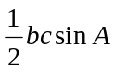
Heron's formula: 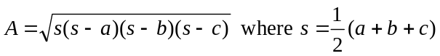
circumference of a circle: 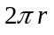

area of a circle: 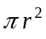

volume of a sphere: 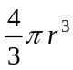
surface area of a sphere: 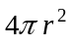

volume of a cone: 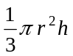
volume of a cylinder: 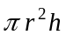

volume of a prism: 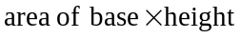
volume of a pyramid: 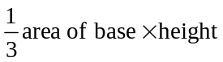

These formulae sheets have been reproduced with permission of the Victorian Curriculum and Assessment Authority, Victoria, Australia.
These formula sheets have been copied in 2008 from the VCAA website www.vcaa.vic.edu.au
The VCAA publish an exam issue supplement to the VCAA bulletin.
Pythagoras’ theorem 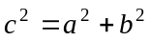

sine rule: 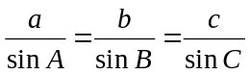
cosine rule: 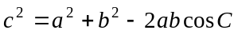

Module 3: Graphs and relations

Straight line graphs

gradient (slope): 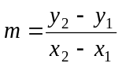
equation: 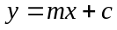

Module 4: Business-related mathematics

simple interest: 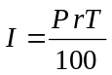
compound interest: 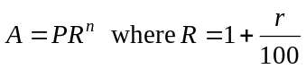
hire purchase: 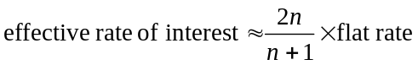

Module 5: Networks and decision mathematics

Euler’s formula: 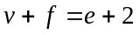

Module 6: Matrices

determinant of a 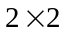 matrix 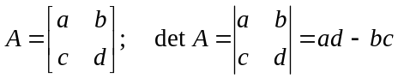
inverse of a matrix 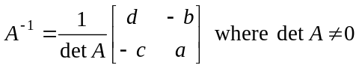

END OF FORMULA SHEET

These formulae sheets have been reproduced with permission of the Victorian Curriculum and Assessment Authority, Victoria, Australia.
These formula sheets have been copied in 2008 from the VCAA website www.vcaa.vic.edu.au
The VCAA publish an exam issue supplement to the VCAA bulletin.

